Lab4-Spatial Filtering

CIS694/EEC693 Image Processing and Learning Methods-2021 Spring

By Hongkai Yu, [h.yu19@csuohio.edu](mailto:h.yu19@csuohio.edu)

Cleveland State University

In this in-class lab, we will practice the Spatial Filtering algorithm for the image enhancement. The image named “boy.png” is a RGB color image with 3 channels.

1. Please make up for the file *DIP.m* to complete the function *DIP.filter_single() for the single-channel spatial filtering*:

% sample call:

I = imread('boy.png');

im=rgb2gray(I);

DIP.filter_single(im, (1/16)*[1,2,1;2,4,2;1,2,1]);

It will show as follow:

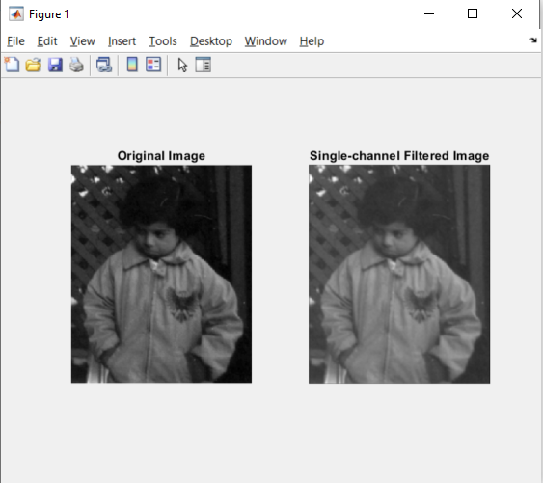

2. Please make up for the file *DIP.m* to complete the function *DIP.filter_multiple() for the multi-channel spatial filtering*:

% sample call:

I = imread('boy.png');

mask = cat(3, (1/9)*[1,1,1;1,1,1;1,1,1], [1,0,-1;2,0,-2;1,0,-1], [1,2,1;0,0,0;-1,-2,-1]);

DIP.filter_multiple(I, mask);

It will show as follow:

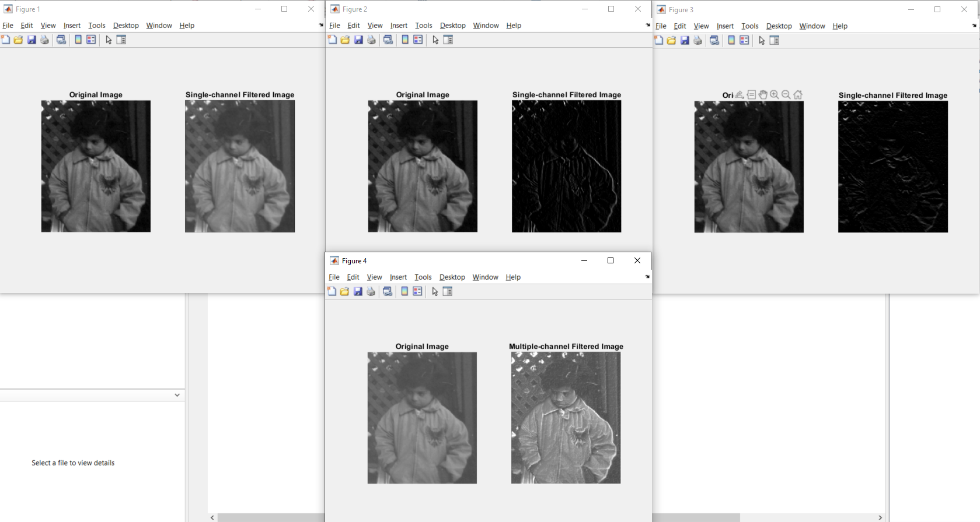

Hint: multiple-channel filtering can be implemented by calling DIP.filter_single() accordingly.